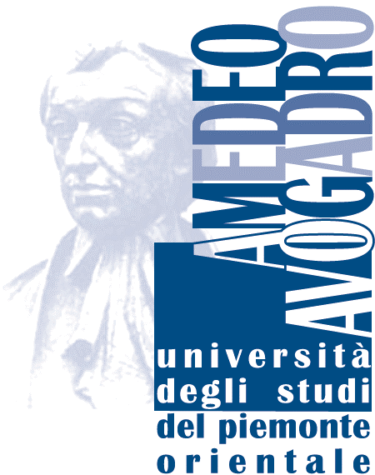

Milano March 17 2015

Open Letter to Members of the Nordic Council

re : NSU

It has come to my attention that the Nordic Summer University will no longer receive funding from the Nordic Council. In my capacity as Former Professor of Moral Philosophy at the ‘Amedeo Avogadro’ University of Eastern Piedmont I feel it appropriate to express my surprise regarding

this decision.

I had the opportunity to join the 2008 edition of NSU in Estonia as keynote speaker – for me an underserved honour – were I presented in three lectures the ongoing debate on what can ethics do for real world issues in contemporary world. These lectures have been published then as a short book by NSU Press: *Normativity within the Bounds of Plural Reasons. The Applied Ethics Revolution*, Uppsala: NSU Press, 2007, 108 pp. ISBN 978-87-87564-07-6

I enjoyed the experience and came back as one more participant for the 2009 edition in Sweden.

I would like to point briefly at some unique features of the School that were such as to raise wonder and enthusiasm in a visitor from another European country like the present writer.

One is multi-disciplinarity. The fact of coexistence of study-groups in philosophy, the social sciences, religious studies, literature and their meeting at plenary lectures, was a breath of fresh air for somebody coming from a country where academic life is still frozen by age, gender, academic status, disciplinary boundaries.

Another is anti-gerontocratic character. For somebody coming from a country where nobody younger than seventy has any say in academic life, the leading role of a young generation of scholars in running the life of the school was an enjoyable surprise.

One more is the delightful mix of academic scholars and people carrying out activities of high responsibility in the real world. For example, the former mayor of Copenhagen was a participant in the 2008 edition.

I hope this is enough to give you a hint of what my experience was. Let me add a detail that may given special authority to my voice. I come from a Southern European country whose politicians have been specializing for half a century in the sport of throwing out of the window the best civil society is able to create, where the most promising academics emigrate and never come back, and so on. I hope the recent decision of withdrawing funding from NSU is not a sign of the ongoing process of European integration, namely that the Nordic countries are trying to keep up with the Southern European Countries in their worst records. Please, think twice, and leave such things to us.

Best regards,



Sergio Cremaschi

Former Professor of Moral Philosophy

Università Amedeo Avogadro

Dipartimento di Studi Umanistici

Via Galileo Ferraris 116

13100 VERCELLI

e-mail: [sergio.cremaschi@lett.unipmn.it](mailto:sergio.cremaschi@lett..unipmn.it)

web page: www.lett.unipmn.it/docenti/cremaschi/ default_en.htm

<http://it.linkedin.com/pub/sergio-cremaschi/37/a44/b88>

home:

Via delle Ande 6

20151 MILANO

phone/tel. +39 02 38007554